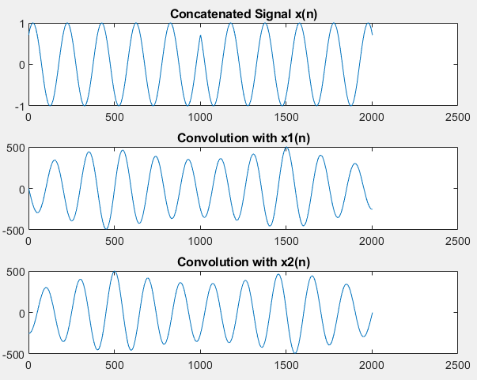
Task 1
fs = 1000;
t = 0:1/fs:1;
fo = 5;
phi = pi/4;

x1 = sin(2*pi*fo*t + phi);
x2 = cos(2*pi*fo*t + phi);

x = [x1 x2];

conv_x1 = conv(x, x1, 'same');
conv_x2 = conv(x, x2, 'same');

subplot(3,1,1); plot(x); title('Concatenated Signal x(n)');
subplot(3,1,2); plot(conv_x1); title('Convolution with x1(n)');
subplot(3,1,3); plot(conv_x2); title('Convolution with x2(n)');
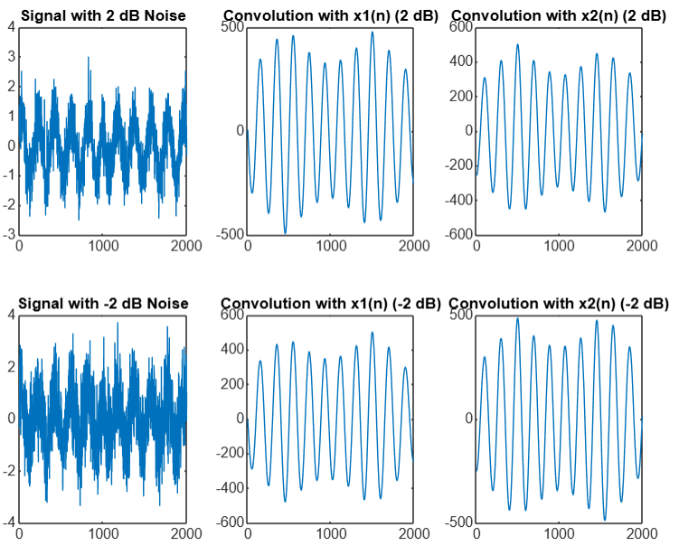
Task 2

fs = 1000;
t = 0:1/fs:1;
fo = 5;
phi = pi/4;

x1 = sin(2*pi*fo*t + phi);
x2 = cos(2*pi*fo*t + phi);

x = [x1 x2];

x_noisy_2 = awgn(x, 2, 'measured');
x_noisy_neg2 = awgn(x, -2, 'measured');

conv_x1_2 = conv(x_noisy_2, x1, 'same');
conv_x2_2 = conv(x_noisy_2, x2, 'same');

conv_x1_neg2 = conv(x_noisy_neg2, x1, 'same');
conv_x2_neg2 = conv(x_noisy_neg2, x2, 'same');

subplot(2,3,1); plot(x_noisy_2); title('Signal with 2 dB Noise');
subplot(2,3,2); plot(conv_x1_2); title('Convolution with x1(n) (2 dB)');
subplot(2,3,3); plot(conv_x2_2); title('Convolution with x2(n) (2 dB)');

subplot(2,3,4); plot(x_noisy_neg2); title('Signal with -2 dB Noise');
subplot(2,3,5); plot(conv_x1_neg2); title('Convolution with x1(n) (-2 dB)');
subplot(2,3,6); plot(conv_x2_neg2); title('Convolution with x2(n) (-2 dB)');

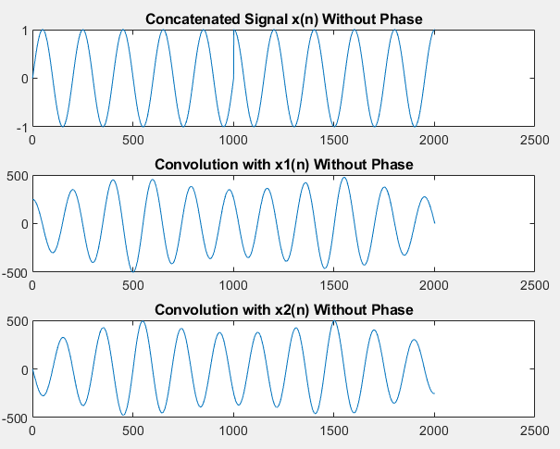
Task 3

fs = 1000;
t = 0:1/fs:1;
fo = 5;

x1_no_phi = sin(2*pi*fo*t);
x2_no_phi = cos(2*pi*fo*t);

x_nophi = [x1_no_phi x2_no_phi];

conv_x1_nophi = conv(x_nophi, x1_no_phi, 'same');
conv_x2_nophi = conv(x_nophi, x2_no_phi, 'same');

subplot(3,1,1); plot(x_nophi); title('Concatenated Signal x(n) Without Phase');
subplot(3,1,2); plot(conv_x1_nophi); title('Convolution with x1(n) Without Phase');
subplot(3,1,3); plot(conv_x2_nophi); title('Convolution with x2(n) Without Phase');

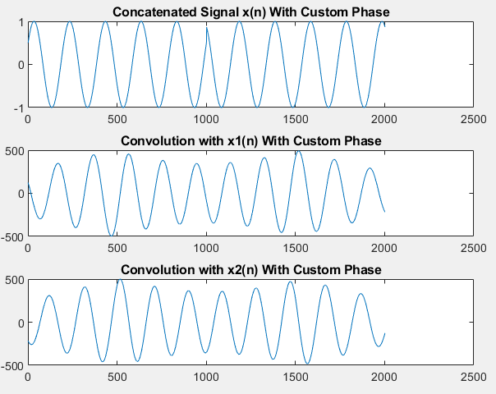
Task 4

fs = 1000;
t = 0:1/fs:1;
fo = 5;
phi_custom = pi/6;

x1_custom = sin(2*pi*fo*t + phi_custom);
x2_custom = cos(2*pi*fo*t + phi_custom);

x_custom = [x1_custom x2_custom];

conv_x1_custom = conv(x_custom, x1_custom, 'same');
conv_x2_custom = conv(x_custom, x2_custom, 'same');

subplot(3,1,1); plot(x_custom); title('Concatenated Signal x(n) With Custom Phase');
subplot(3,1,2); plot(conv_x1_custom); title('Convolution with x1(n) With Custom Phase');
subplot(3,1,3); plot(conv_x2_custom); title('Convolution with x2(n) With Custom Phase');

